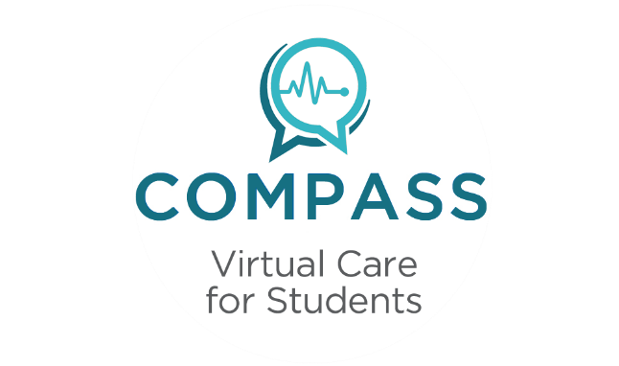

Tested quickly, safely, and discreetly

The Teladoc service provides a more convenient option to getting tested for STDs.
It allows your students to skip the trip to a doctor’s office and go straight to a testing location.
Note: Many STDs are preventable, and some are curable.

1 2 3 4
Students can choose
to talk to a doctor
by phone to discuss
any questions or
concerns.
Talk to a doctor
View
results online

Choose a lab
Completing a short questionnaire

Students call or go online
and click “Get
a sexual health
screening” to
get started.

The results and
next steps will
be available
online within
3 business days.
They select the most
convenient testing
location to them.

To ensure privacy, the results will never be saved into the member history.

